
Vesterbrogade 95 H, 1620 København V, DENMARK
TEL: +45 33 21 01 35 FAX: +45 33 24 04 95

NEW RELEASE
ARTIST: HALPH  TITLE: Answering Machines  CATALOGUE NO.: PONY01CD  BARCODE: 5709498203126  CATALOGUE NO.: PONY01LP  BARCODE: 5709498203133  LABEL: PONYREC  STYLE: Indie Rock  ORIGIN: Denmark  RELEASEDATE: 24/1-2005 | 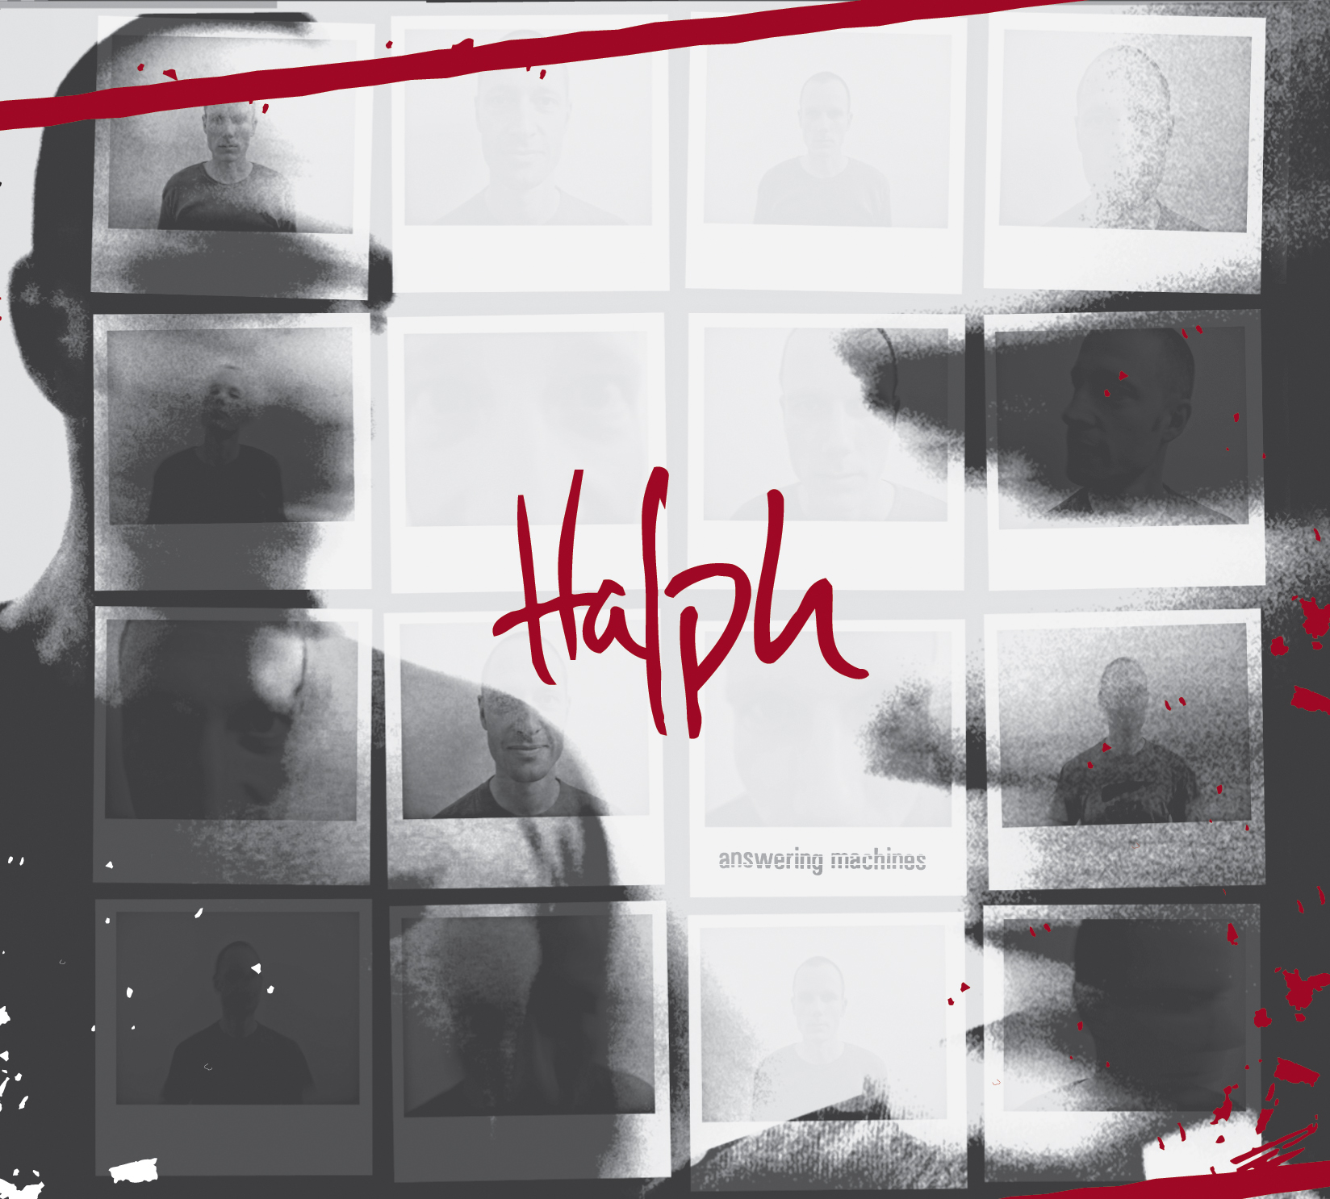

HALPH : Answering Machines
Debutalbum by the danish rock duo Halph (Thomas Nygaard & Karsten Bagge)  It took only one year, from where the idea of Halph was put to demotape for the first time, to where this danish duo had an album out, and was touring as support of one of the biggest rockgroups in denmark, Kashmir.  But that´s pretty much how it has been from the get go.  Fast forward moving, as is the music.  The songwriter universe of Thomas Nygaard, takes a closer look at life, dealing with the world as he see's it; close to thirty, as a father, a lover, a peacekeeper, a whimp, a good friend.....directly.  The duo of guitarplayer/singer Thomas Nygaard and well renowned jazzdrummer Karsten Bagge, have set out to challenge their listeners with a gritty (at times brutal) guitar sound, an advanced rhytmic feel and spoken word on top, through must of their songs, knowing all to  well that it will offend some people, but the reward is as they say; "the ones that get it....are gonna LOVE IT!!"  Now it's time to give the rest of the world the chance that is Halph. | TRACKLISTING:  01 Bad Wiring  02 Back Again  03 Calm  04 No Fear  05 Backdoor  06 Needing  07 Orange  08 Evil One  09 Black drive  10 Small  www.halph.dk  www.ponyrec.dk
For more information, photos, interviews etc.,
please contact Jan: +45 33 21 01 35 / jan@vme-group.com
Ponyrec: contact@ponyec.dk

