
Vesterbrogade 95 H, 1620 København V, DENMARK
TEL: +45 33 21 01 35 FAX: +45 33 24 04 95

NEW RELEASE
ARTIST: TENDERLOUD  TITLE: Shadow Red Hand  CATALOGUE NO.: PONY02CD  BARCODE: 5709498203201  CATALOGUE NO.: PONY02LP  BARCODE: 5709498203195  LABEL: PONYREC  STYLE: Americana  ORIGIN: Denmark  RELEASEDATE: 28/2-2005 | 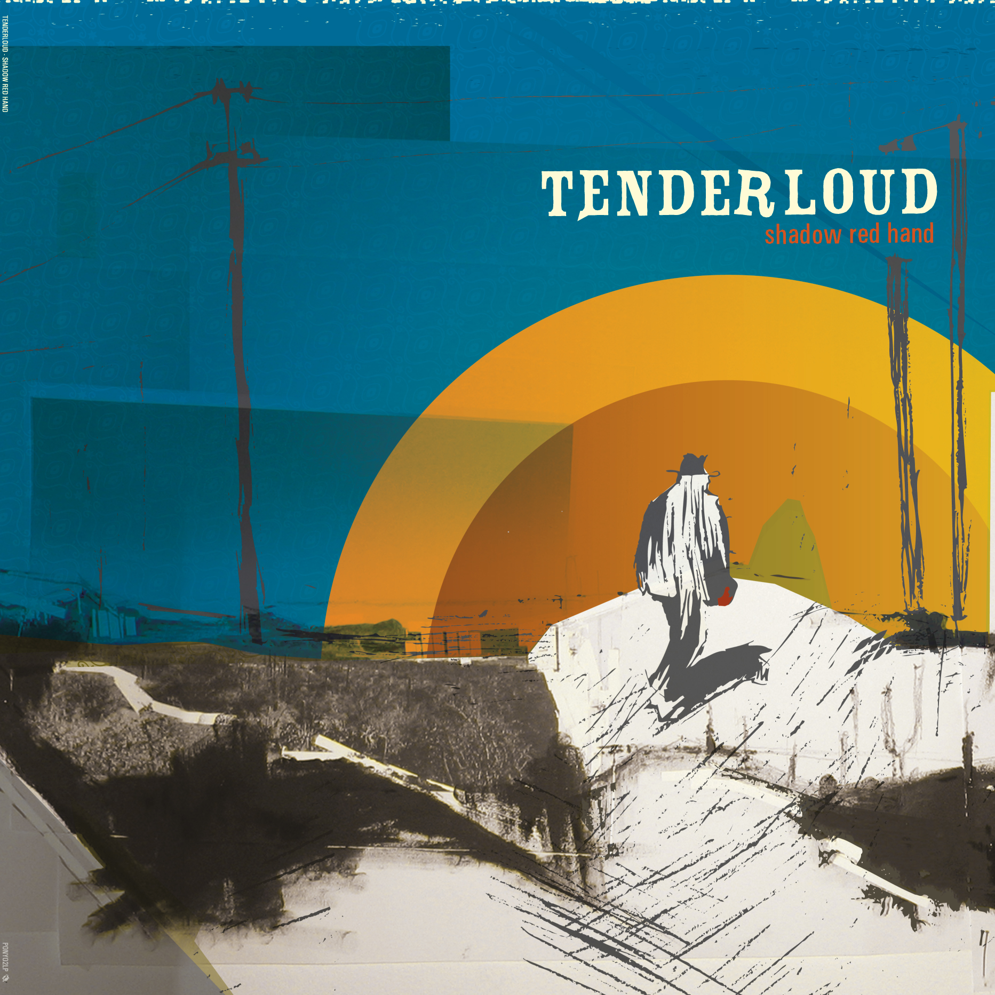

TENDERLOUD: Shadow Red Hand
Uncompromising debut album from Scandinavia’s finest americana-rock band, Tenderloud  In the music you will find young desperados, the wild at heart, quiet men balancing between beauty and heartbreak, sunshine and melancholia. The varied vocals are central to the dusty sound of Tenderloud, but there are a number of influences present. Traditional country instruments like banjo, dobro and violin are confronted with a European rock sensibility.  Shadow Red Hand is mixed and engineered by Simon Alpin of Willard Grant Conspiracy and Nick Hunt and mastered by Adam Nunn, Abbey Road Studios, London. The band itself is augmented by several guests on their album. Among these are WGC-members Josh Hillman (violin) and Simon Alpin (harp).  Since forming, Tenderloud has established themselves as one of the most exciting live-act on the Copenhagen rock-scene and was touring Denmark as support for St. Thomas on his Hey Harmony-tour and Willard Grant Conspiracy on their latest European tour. | TRACKLISTING:  01 1956  02 Pass Me By  03 Liquor Eyes  04 Happy Days  05 White Lines  06 45 Mile Man  07 Horses of the Woods  08 Shadow Red Hand  09 Texas Down  10 Down My Way  11 Old River Town  12 Liars Banquet  www.tenderloud.dk  www.ponyrec.dk
For more information, photos, interviews etc.,
please contact Jan: +45 33 21 01 35 / jan@vme-group.com
Ponyrec: contact@ponyec.dk

